Writing a Control Panel for the SIMH System
Revised Dec-2020 for SIMH V4.0

COPYRIGHT NOTICE

The following copyright notice applies to the SIMH source, binary, and documentation:

Original code published in 1993-2016, written by Robert M Supnik
Copyright (c) 2017-2020, Roberto Sancho

Permission is hereby granted, free of charge, to any person obtaining a copy of this software and associated documentation files (the "Software"), to deal in the Software without restriction, including without limitation the rights to use, copy, modify, merge, publish, distribute, sublicense, and/or sell copies of the Software, and to permit persons to whom the Software is furnished to do so, subject to the following conditions:

The above copyright notice and this permission notice shall be included in all copies or substantial portions of the Software.

THE SOFTWARE IS PROVIDED "AS IS", WITHOUT WARRANTY OF ANY KIND, EXPRESS OR IMPLIED, INCLUDING BUT NOT LIMITED TO THE WARRANTIES OF MERCHANTABILITY, FITNESS FOR A PARTICULAR PURPOSE AND NONINFRINGEMENT. IN NO EVENT SHALL ROBERTO SANCHO BE LIABLE FOR ANY CLAIM, DAMAGES OR OTHER LIABILITY, WHETHER IN AN ACTION OF CONTRACT, TORT OR OTHERWISE, ARISING FROM, OUT OF OR IN
CONNECTION WITH THE SOFTWARE OR THE USE OR OTHER DEALINGS IN THE SOFTWARE.

Except as contained in this notice, the name of Roberto Sancho shall not be used in advertising or otherwise to promote the sale, use or other dealings in this Software without prior written authorization from Roberto Sancho .

1. Overview 4
2. Integrate Control Panel in a SimH simulator for first time 4
3. Control Panel Modeling 6
3.1 Control Panel Definition File 7
3.2 Control Definition 8
3.2.1 Form 1: Single control 8
3.2.2 Form 2: Generic control 8
3.2.3 Form 3: Single control based on Generic control 9
3.2.4 Form 4: Control Array 9
3.2.5 Base coordinates 10
3.3 Control Bitmap Images 10
3.4 Other Tags 12
3.5 Options 13
3.6 Control Panel Icon 14
3.7 Example 14
3.8 Maximum values 15
4. Writing Control Panel’s C code 15
4.1 Event processing 15
4.2 Binding 17
4.3 xxx_cpanel.c layout 18
4.4 API 19
4.4.1 Control State Management 20
4.4.2 Control Dynamic Images 21
4.4.3 Control Panel issued SCP commands 23
4.4.4 Options Management 24
4.4.5 Variables 24
5. Using Control Panel 26
5.1 CPU execution Mode 27
5.2 Interactive Mode 30
5.3 SCP commands 30
5.4 Debugging 33
6. Ways to create a Control Panel 34
6.1 Using tags to generate graphics and texts 34
6.2 Using one PNG file that holds several states 34
6.3 Using several PNG files, one for each state 34
6.4 Panels done so far 35
6.4.1 HP 21XX family 35
6.4.2 IBM 700/7000 family 35
6.4.3 IBM 650 36
6.4.4 IBM NORC 36

Overview

SIMH (history simulators) is a set of portable programs, written in C, which simulate various historically interesting computers. This document describes how to design, write, and check out a new computer control panel for SIMH.

As a general guideline, the steps to do are the following:

- Integrate control panel code in SimH
- Create a Control Panel Definition file that describes the visual look and the controls that can be handled by user (switches, buttons, …) and by the CPU (lights, leds, …)
- Wrtie C code to implements the control panel logic using the provided API
- Create a script file with scp commands to start up the simulation using control panel

The following sections will discuss each one of these points

Integrate Control Panel in a SimH simulator for first time

To build a control panel, it is necessary to prepare the build environment to support SDL graphics

- Add Preprocessor Definitions
- USE_SIM_VIDEO
- HAVE_LIBSDL
- CPANEL
- Apply #if defined(CPANEL) patches to these already existing SimH files:
- sim_video.c
- sim_video.h

Now add control panel support files to source tree. ”xxx” is the simulated machine:

- Add these SimH files to source tree.
- cpanel.c
- cpanel.h
- cpanel_vid.c
- cpanel_vid.h

- Modify these files (one, or several) to add a new device to simulated machine

- xxx_defs.h / xxx_sys.c / xxx_cpu.h / xxx_cpu.c
- Add a new device variable placeholder for linker (typically in xxx_defs.h)

#if defined(CPANEL)
extern DEVICE cp_dev;
#endif

- Add a new device to sim device list (typically in xxx_sys.c)

DEVICE *sim_devices[] = {
…
#if defined(CPANEL)
&cp_dev,
#endif
…

- Hook control panel to the simulator core in xxx_cpu.c

- Add at beginning of file
#if defined(CPANEL)
#include "cpanel.h"
#endif

- Locate function

t_stat sim_instr (void)
{
…
/* Main instruction fetch/decode loop */
while (reason == SCPE_OK) {
/* loop until halted */

- Add under while:

/* Main instruction fetch/decode loop */
while (reason == SCPE_OK) {
/* loop until halted */
…
#if defined(CPANEL)
if (cpanel_on) {
// do control panel event processing
reason = cpanel_interval_refresh();
if (reason != SCPE_OK) break;
}
#endif
…

- Hook control panel to the simulator core in scp.c

- Add

#if defined(CPANEL)
#include "cpanel.h"
#endif
…

- Locate function
char *read_line_p (const char *prompt, char *cptr, int32 size, FILE *stream)
…
if (prompt)
printf ("%s", prompt);
cptr = fgets (cptr, size, stream);

- Replace by

#if defined(CPANEL)
cptr = cpanel_fgets(prompt, cptr, size, stream);
#else
if (prompt)
printf ("%s", prompt);
cptr = fgets (cptr, size, stream);
#endif

- Create a new file for panel logic implementation and add it to source tree (more on this later)

- xxx_cpanel.c

Control Panel Modeling

Control Panels (CPs) are modeled like devices SimH: defining callbacks functions for main events. In the case of CPs, these events are initialization, computer reset, refresh, and clicking on CP.

These events handles the logic of CPs, how CP reacts to user initiated events and to internal simulator changes. However, the events do not describe the visual representation of panel.

The visuals are responsibility of Control Panel Definition File (DF). It is a text file that describes how panel looks like.

CPs are based on controls. A control is defined by its name and properties, a represents a bitmapped image of a given Width (W) and Height (H) in pixels, which is drawn on GUI window at position X,Y in pixels. Coordinate 0,0 is top left corner of window.

A control can have several states, ranging from zero, one, two or more. On controls with 1 or more states, each state has its own bitmap that is automatically drawn on GUI when selected.

For example, control Led_A_1 can be defined with two states. State 0 has the image of led unlighted. State 1 has the image of led lighted. On xxx_cpanel.c a routine can set the state to 1 to “lit” the led, or 0 to turn it off.

Control with one state are useful for static images, like labels, logos, the main CP frame.
It is possible to bind a routine to a control. This routine will be called automatically when user clicks on the GUI, over the control (that is, clicks in coordinate range X to X+W, and Y to Y+H). This is called the OnClick callback.

For example, control Switch_A can be defined with two states. State 0 has the image of Switch Up, and State 1 the image of Switch down. Its OnClick callback can ask the control for its current state, change the controls state., and perform the actions in simulations to reflect the logic of switch.

More complex controls can have more states: for different led’s intensities, for 3 position switches, multiposition knob selectors, push down buttons that can be illuminated pushed or unpushed (4 states), etc.

DF defines the controls in a CP. The xxx_cpanel.c implements the OnClick events and bind them to controls. Whiz this generalized model it is possible to create CPs with great flexibility and little non-core-logic coding.

There are two special cases on controls:

- If a control is defined with zero states, it will not draw. It is transparent, but can be bind to a OnClick event, so it is useful to define a click area over another control image. This is used for example for 3 position switches. Control is the full switch with 3 states that reflects the 3 possible positions. However, this control has no OnClick event. Instead, two transparent controls are defined over the switch, on top and bottom where the user will chick to manage the switch. These transparent controls have the OnClick event that changes the Switch state to pos 1 to 3, and to implements the actions to be taken into simulation.

- If a control is defined ta coordinate X = -1, it will not be drawn even if has states defined. This is useful to implement generic controls on which other ones are based. For example, it is possible to define a Led control with two states, and create many Leds based on it, without having to define the states for each one.

It is possible to group several controls into a control array to manage them at once. This is very useful for example for register displays based on n lights that is goes on and off representing one bit each one. Or for pushbuttons that turns on/off the bits of register.

Individual controls are called single controls, a group of single control is a control array. Controls can thus refer to a single control or to a control array.

A control array is just defined by naming the controls that belong to it. It is possible to set the state of a control array to a value of n. This will set to 1 or 0 the state of each one of the single controls: bit n of control array state sets the state of single control n to 0 or 1. It is also possible to set the state of controls in control array to any other value.

Control Panel Definition File

Control Panel Definition File (DF) describes a Control Panel (CP).

The DF is a text file thay contains lines with this following syntax:

Tag = value, value, value ; comment

Tags can have one or several values. Comments must have at least one space after the semicolon.

Tags are not case sensitive. Values depends on tag semantics. Spaces can be used freely to format the line. It is not allowed to split the tag or tag values across several lines.

The general layout of DF is this one:

ControlPanelName=HP-2116A (Basic Schematic graphics)
ControlPanelType=HP2116
; load external bitmaps
LoadImage=img0,cpanel_bitmap_0.png
; Control panel general background (must be first control)
ControlName=Background
ControlName= …
ControlPanelName describes the panel name (surprise!) up to 255 characters long. This is the name that will be shown in the windows tittle. Case and spaces are kept.

ControlPanelType describes the type name of panel to be handled by xxx_cpanel.c. It is a string up to 32 chars, case insensitive. No spaces are allowed in the name.

LoadImage allows to load external image files (PNG format)

DF describes the controls to be used. The minimum is one control, the first. W and H values of this control defines the Width and Height in pixels of the GUI window that will hold the control panel. This control is the one that holds the general CP background.

In addition, it is possible to define control arrays (after the first ControlName)

ControlArrayName= …

Control Definition

To define controls several forms are available:

Form 1: Single control

ControlName=Name
XYWH=10,20,1000,600 nStates= 1

This form defines a single control named “Name” (case insensitive, up to 32 chars, no spaces allowed). Defined the position at X=10, Y=20, with a Width and Height W=1000, H=600. The coordinates are relative to GUI window (0,0 top left corner). This control has only one state. A control can have up to 255 states.

At this point, the control state’s bitmaps are created in SimH memory. They are filled with transparent color. The bitmaps have nStates x W x H pixels in total. There is a limit of 16 millions of pixels to be used by the sum of all controls (to prevent eating all the computer’s memory). This limit is set by MAX_PIXELS constant in cpanel.c file.

Form 2: Generic control

ControlName=Indicator_Light
WH=100,10
nStates=2

On generic controls, X and Y are not specified as control is not shown. Only Width and Height are set. Except that, it is the same as a single control.

Generic control can be set to be copied when referenced, or to have only one common instance of generic control. To have only a common instance, use:

ControlName=Indicator_Light
WH=100,10
nStates=2
SameAsByReference

Form 3: Single control based on Generic control

ControlName=IND_Extend
XYSameAs=190,350,Indicator_Light

This form defines a single control that is based on a generic control. The X and Y coords to be used are given. Then the name of the control to copy. The coordinates replaces the ones defined on control copied, and are also relative to top left corner of GUI window.

The name of control to copy can be a generic control or a single control, but not a control array. Name control must already been defined. It is not possible forward referencing.

All the data of is copied: the W and H, the number of states.
If Generic control has SameAsByReference tag set, then a reference to the generic control bitmap is set on new control. If Generic control has not SameAsByReference tag, then the bitmap from generic control is copied on new control defined.

The following table summarizes the benefits of using or not using SameAsByReference on generic control

Generic control has NOT SameAsByReference | Generic control defined with SameAsByReference
Bitmap for new control is a copy of generic control | Bitmap for new control references the generic control bitmap
Uses bitmap memory on each new control defined | Do not use bitmap memory on new control
It is possible to modify the new control bitmap states to customize the control | Cannot modify states (the modification is set on the generic control, an thus applies to all controls that uses this generic control)

Form 4: Control Array

ControlArrayName=Name
ControlArrayItems=Name0, Name1, Name2 …
ControlArrayItems=Name5, Name6, Name7 …

Defines the control array Name, and the single controls that belongs to it (Name0, Name1, …)
Each one of these should have already been defined, and should be single controls: cannot be control arrays. If a generic control is used there is no error, but this control will not be displayed (as it is generic).

The list of controls can be splitted in several lines as shown. First control (Name0) will be mapped to bit 0, second one to bit 1, etc. when setting the control array state.
A control array can hold any number of controls (up to the maximum defined in SimH compilation). Nevertheless, only the first 64 will be mapped to the control array state.

Base coordinates

Form 1 (Single control) and Form 3 (single control based on generic) specify the coordinates X,Y of the control visuals in the GUI window. These coordinates are relative to top left window corner (0,0 coordinate).

It is possible to specify the coordinates relative to another base origin. This is usefull when populating controls for a “section” of the main background, and also eases moving them around to another position.

BaseXY=X,Y

Specifies the new base origin. After this tag is processed, the base values given will be added to the X and Y coordinates specified in XYWH and XYSameAm tags.

Default initial value for BaseXY is 0,0

Another syntax is available:

BaseXY=+|-X,+|-Y

Specifies the new base origin but relative to the current one.
Suppose current base is X=100,Y=200. The tag BaseXY=+100,-10 will set the current base to X=200,Y=190. Note that a minus or plus sign is required in both X and Y coordinates, even if they are zero (use +0)

Control Bitmap Images

On Form 1 and form 2 (single and generic controls) it is possible to define the bitmapped image to be drawn for each state of control. Remember that states images are defined as default with transparent color, so if no image is defined, nothing will be drawn on GUI when state is set.

There are two ways of creating an image for a given control‘s state: 1) define what to put on image, and 2) grab the image from a PNG format external image file

To define what to put on state image you can use the following tags:

StateRgb=n,r,g,b

Where n is the state number being defined (0 to number of states defined minus one).
R,g,b are the color components (from 0 (no color) to 255 (full color))

This tag fills all state’s image with pixels of given color, thus creating a rectangle size W x H of that color.

StateRgbArea=n,r,g,b,x,y,w,h

Where n is the state number (same as above) and r,g,b the color to be used (same as above). This tag draws a rectangle on the state image at position x,y and width, height w,h. Position 0,0 is the top left corner of state’s image (that has a size of W x H as defined in XYWH= or WH= tag). It is possible to use several tags in sequence, thus effectively painting the state’s image with complex bitmaps. If w or h is set to 1, it is same as drawing an horizontal or vertical line.

StateRgbCircle=n,r,g,b

Where n is the state number (same as above) and r,g,b the color to be used (same as above). This tag draws a circle/ellipse on the state image centered on the box defined by width, height of control. The circle/ellipse is filled with given rgb color.

Note that before drawing the circle, the pixel at position 0,0 is checked. If this pixel has color, circle is drawn antialiased with current image. If this pixel is transparent then no antialiasing is done.

Example
nState=1
StateRgbCircle=0,…

states filled with transparent pixels when create. First item drawn in state 0 is the circle, so pixel at 0,0 will be transparent. No antialiasing is used

nState=1
StateRgb=0,…
StateRgbCircle=0,…

state 0 is fille with color before drawing the circle, so pixel at 0,0 will be not transparent. Antialiased circle is drawn

StateRgbText=n,r,g,b,x,y,text

Where n is the state number and r,g,b the color to be used. This tag draws text on the state image starting at position x,y. Text can be up to 255 chars long. Case and spaces are preserved. Only chars 32 up to 127 are available. The position x,y is the top left corner of first character. Font used is 5 pixels horizontal x 7 pixels vertical, with a spacing between character of 2 pixels. Text is drawn with given rgb color

If color r is 999, then the color is set to transparent. This allows to create masks.

To get states image from an external file you can use the following tags:

LoadImage=Name,filename

This tag opens the given filename an read its contents as a PNG format image. Filename coan include path. If no path is given, it is opened assuming it is in same directory as DF file. The image is stored in SimH memory (memory is free when DF processing finishes). The Name give (up to 32 chars, no spaces, case insensitive) allow to reference this image.

This tag is to be used at the beginning of DF file, not as a tag when defining the control states, as described in DF general layout seccion.

StateImg=n,x,y,Name

This tag fills the given control state n with pixels from image already loaded with LoadImage tag and named as Name. It takes pixels form Name image starting at position x,y, and copies a rectangle size W x H (control’s size) to state image.

It is possible to control the height of image on control with the following tag

Height=n

This tag allows to share a common image and use a specific height for each control.

Bitmap Images used can have transparent pixels. To do this, a color of image is defined to be interpreted as transparent. To define which is the image’s transparent color, the following tag is used

TransparentColor = W | B | R , n

This tag allows subsequent StateImg (s) to replace White/black/red pixels by transparent color with the following rules.

if W, tranparent pixel is the one that has r,g,b > n,n,n
if B, tranparent pixel is the one that has r,g,b < n,n,n
if R, tranparent pixel is the one that has r-g >n ,r-b > n

Transparent color definition applies to all subsequent StateImg tags until reset by nState or XYSameAs tag.

StateImgAlpha=n,b,m

Modifies the image for control state n. The new image is composed by getting image from state b (the base image), and applying image from state m as an alpha mask.

state n image = state b image MASKED with state m as alpha mask

the state to be used as b or m can be the same as n.

When the control is to be painted on main Window GUI, the following rule is observed:

- if pixel in mask image was white, then the base pixel will be 100% visible, background 0% visible

- if pixel in mask image was black, then the base pixel will be NOT visible, background fully visible visible

Other Tags

As said, it is possible to construct a complex control’s state image using one or several StateXXX tags in sequence. Remember that coordinates used in StateXXX are relative to current control, not to main CP GUI window.

It is possible also to define the initial state for this control with tag

InitialState=n

If no InitialState tag is given, the initial state of control is zero.

Controls are drawn in the order they are defined. This is important as controls can overlap.

It is possible to define controls that simulated different levels of intensity of (e.g.) a led. To do this, it is necessary to define the control with

- More than 2 states. For example, 32: StateImg=32
- State 0 defined for 0% intensity (say led light off)
- State 1 defined for 100% intensity (say led light on)

Then the tag

AutoStates

Will create the remaining states (in the example from 2 to 31). The image in each one is mixes the image 0 and 1 in percentage of (current_state – 1) / total number of states

During the processing of DF file, it is possible to generate text comments (uo to 255 chars) to be displayed on console, using the tag

echo=text to output to console

Options

It is possible to define parts of the DF that will be processed or not based on options. These options are set with scp command set cpanel option=Name, so the same DF can behave different based on user/script choices.

In DF file, several tags are defined to manage options, There are similar to #define macros used in C language.

ifopt=Name ifnopt=Name
…
Elseif=Name
…
else
…
endif

ifopt allows the processing of following lines if Name option is defined. Ifnopt if it is not defined.
Elseif tests for Name to be defined, to allow multiple tests (if’s cannot be nested). Elseif and Else are not mandatory. Elseif can appears many times, else only once.

The option Name defined by set cpanel can be in form set cpanel option=OptName/Param

In this case, the tag must contain the exact same literal

ifopt=OptName/Param ifnopt=OptName/Param
…
Elseif=OptName/Param
…
else
…
endif

In DF file, an option can be defined or undefined

defopt=Name
undefopt=Name

When using the OptName/Param syntax, it is possible to have parametric options

defopt=OptName/Param

remove whatever Param is being defined with OptName previously and replace it with new given param

Control Panel Icon

if control defined with name "icon", its bitmap image for state 0 will be used as GUI window icon. Max size 32x32. If Size is bigger, only 32x32 pixels from top left corner will be used. If image size is less than 32x32, image will be centered on icon.

Example

CP light generic control using tags to draw it. When light is off (state 0) it is a grey circle over a dark background, When lit on, it becomes an orange circle over same background

ControlName=Light
WH=16,16 ; It's a generic control
nStates=2 ; Two states: 0 (off), 1 (on)
StateRGB=0,32,32,32 ; state 0 background, same as
; CP background color
StateRGBCircle=0,72,72,72 ; state 0 (off) defined as
; red,green,blue color (grey)
StateRGB=1,32,32,32 ; state 1 background
StateRGBCircle=1,234,176,81 ; state 1 ( on) orange

Same control but using and external image file, and generation 32 intermediate intensity levels
LoadImage=Img0,hp2100.png

ControlName=Light
WH=16,16
nStates=32
StateImg=0, 0,601,Img0
StateImg=1,20,601,Img0
AutoStates

File hp2100.png has in position 0,601 (left bottom of image):

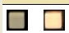

This example allows the usage of different external files depending on option selected

ifopt=photo
; photorealistic images
LoadImage=Img0,IBM709_State0_512p.png
LoadImage=Img1,IBM709_State1_512p.png
Else
; enhanced readability version of the above images
LoadImage=Img0,IBM709_State0B_512p.png
LoadImage=Img1,IBM709_State1B_512p.png
endif

Example using OptName/Param syntax

DefOpt=ibm533/visible
Ifopt=MainCpuOnly
; main cpu panel, ibm 533 is not visible
DefOpt=ibm533/novisible
Else
; any other option
Endif
…
Ifopt=ibm533/visible
…
endif

Maximum values

On cpanel.c source code some constants defines the maximum allowed values. They are set to reasonable values, but can be changed

#define MAX_CONTROLS 1000 // max number of controls in CP
#define MAX_CARRAYS 128 // max number of controls arrays
#define MAX_CARRAYITEMS 1000 // max num of controls in control arrays
#define MAX_PIXELS 16*1024*1024 // max number of pixels in CP
#define MAX_IMAGES 32 // max number of images loaded
#define MAX_OPTIONS 255 // max number of chars to store options

Writing Control Panel’s C code

Ok, now you have a great looking control panel based on a bunch of PNG files, with several images for buttons, switches, leds, etc.

Now it is the moment to write the C code that implements the working logic for all of these ones. Whats happens when the user press a button: A scp command is issed? An internal cpu variable is changed?

Event processing

To implement a CP in SimH it is necessary to add some callback routines that are called by simulation as a response to events. These callbacks are called only if they are defined (i.e. != NULL).

The callbacks are:

- Init Callback: called when CP is created on scp command set cpanel on
- Done Callback: called when CP is created on scp command set cpanel off
- Reset Callback: called when simulator devices are reset (scp command reset)
- Refresh Callback: called at a rate of 60 times per second to update the visible CP state.
- OnClick Callback: called just after Refresh Callback if user has click on a control that has his callback defined.
- TickIntensityCount Callback: to keep track of fast bit changes on registers

Init callback is used to initialize internal CP variables. This callback is called after the DF has been processed, as very last step of set cpanel on processing. So when Init callback is executed all controls states and properties has been set, and it’s bitmap has been loaded. Init callback is the place to 1) do some posprocessing to control state bitmaps if needed, and 2) allocate dynamic memory for control panel if needed

Done callback is used to clean up and terminate control panel. It is the place to free any dynamic memory used by control panel. This callback is called as first step of set cpanel off processing

Reset can be used to allow the CP to respond to simulation reset (e.g. lighting the reset led to signal the user a reset has occurred)

Refresh call is responsible of setting the control state’s based on current simulator internal variables (CPU registers, etc.). Refresh can be called when CPU is running or stopped (sim_is_running == 0).

After calling refresh callback, the simulator paint all control’s current state image. The images are paint on control creation order, so later defined can overlap previous defined ones. Controls with nState=0 are not painted (for efficiency, only state changes are painted).

For each CP, there are only one Init, Reset and Refresh callback. Nevertheless, each single control or control array can have (or not) a OnClick event associated. Can the same callback shared by all, by some, or each control can have its own callback.

When the user clicks on GUI, simulator determines checks all single controls in the order they are created. If mouse coordinates are

- inside control coordinates (defined by its X,Y,W,H)
- X coord >= 0 (Generic controls has X coord as -1 so they are not sensed)

Then the control is identified as clicked on CP_Click variable.

As all controls are checked in creation order, if two controls overlaps ay mouse click position, the control finally identified as clicked is the defined later (i.e. defined in higher line number in DF file). This is relevant for example on multiple position selectors. DF must define the selector first, and afterward the DF must define the clickable areas on control.

Once all single controls are checked and the later-defined one clicked identified, all the control arrays are checked to see if the clicked control belongs to one of them. If so, the control array is identified as clicked in on CP_Click variable.

If clicked control belongs to a control array, the control array OnClick callback is used (if any). Else, the single control owns OnClick callback is used (if any).

OnClick callback is called on GUI mouse click event. OnClick will be called twice: one time on mouse button pressed, and once more on mouse button release.

Onclick callback can determine the reason of being called by inspecting CP_Click.KeyPress_KeyRelease variable. Possible values

1: callback called on mouse button pressed
2: callback called on mouse button released

TickIntensityCount callback is called 10 times on each frame.. It allows to simulate very fast blinking lights like instruction counter regirster. These lights blinks so fast that the human eye is not been able to track the light going on and off. Instead, the human eye sees the light at dimmed at lower intensity. For example, if a register light is on 1 cycle and off the following 3, it is seen by user at 25% of its full intensity.

Binding

DF defines the CP’s controls on runtime. Nevertheless, xxx_cpanel.c implements at compile time the callbacks that models the logic of CP and should manipulate the CP’s controls.

To allow this the CP controls created at runtime (based on DF tags) are bind to variables on CP creation. This appends during the execution of scp command set cpanel on.

The command set cpanel on does the following actions

- Reads the cpanel device attached file and processes it as DF
- Creates the controls and loads the external image files (if any)
- Each control is given a Control Identifier (CId): and integer value that allows to use the control with the CP API calls
- Variable binding: the specified variables are assigned the CId value for the specified control name.
- Init callback is called
- GUI window is created and displayed
- Refresh callback is called

The binding is controlled by a CP_TYPE array created in xxx_cpanel.c file:

CP_TYPE cp_types[] = {
{ "HP2100", 1, cp1, &cp1_Refresh, &cp1_Init, &cp1_Reset},
{ "HP1000", 2, cp2, &cp2_Refresh, NULL, &cp2_Reset},
{ NULL }
};

Here is the definition for control panel type “HP2100”. When DF is loaded, the tag ControlPanelType= is checked against first CP_TYPE’s array value. If it match, then the DF controls are bind to variables specified in cp1 array. This way it is possible to implement at once several different control panel logics at once.

The variable cpanel_on is set to the value of second CP_TYPE array value. The code can check this variable to know what is the type of loaded DF.

In cp_types array are also defined Refresh, Init, Done and Reset callbacks for each panel type. Can be different, the same or NULL.

cp1 is an array of type CP_DEF also created in xxx_cpanel.c file:

CP_DEF cp1[] = {
{ &Reg_T, "Reg_T", NULL , 0 },
{ &BTN_Clear_SW_Reg, "BTN_Clear_SW_Reg", &cp1_OnClick , 0 },
{ &SW_Reg, "SW_Reg", &cp1_nClick_SW_Reg, 2 },
{ NULL }
};

Here xxx_cpanel.c file variable Reg_T is defined as to be bind to the control with name “Reg_T”; then OnClick callback is defined (can be NULL). On variable binding, Reg_T will receive the CId of control named Reg_T. Last parameter indicates what type of panel binds this variable. 0 mean all panels of any type. >0 only binds the variable when processing the given panel type.

It is possible to define only controls to be bind only if some option is defined. Example

CP_DEF cp[] = {
{ &IBM650.Reg_MT_SEL_N, "Reg_MT_SEL_N", NULL, 0, "ibm652/1" },
{ &IBM650.Reg_MT_OPER, "Reg_MT_OPER", NULL, 0, "ibm652/1" },
{ &IBM650.Reg_INQUIRY, "Reg_INQUIRY", NULL, 0, "ibm652/1" }
};

These controls only will be bound (each IBM650.Reg_xxx variable will get a control id) if option “ibm652/1” is defined either by a set options cpanel= or by a DefOpt tag. If option “ibm653” is not defined, each IBM650.Reg_xxx will get a -1 value, and none of these controls have to be defined in DF

xxx_cpanel.c layout

The general layout of xxx_cpanel.c file is as follows:

// xxx_cpanel.c needs the preprocessor symbol CPANEL to be defined
#if defined(CPANEL)

#include "hp2100_defs.h" // includes to access the data to
#include "hp2100_cpu.h" // show in Control Panel
#include "cpanel.h"

CP_DEF cp1[]; // declare forwards
void cp1_Reset(void);
void cp1_Refresh(void);
void cp1_OnClick_SW_Reg(void);
void cp1_OnClick(void);

CP_DEF cp2[];
…

#define IS_HP2100 1 // define CP type contants. must start on 1
#define IS_HP1000 2
…

// control panel available types
CP_TYPE cp_types[] = {
{"HP2100", IS_HP2100, cp1, &cp1_Refresh, &cp1_Init,
&cp1_Reset, &TickIntensityCount},
{"HP1000", IS_HP1000, cp2, &cp2_Refresh, NULL, &cp2_Reset, NULL},
…
{ NULL }
};

// control variables (to be binded)
int Reg_T, Reg_P, Reg_M, Reg_A, Reg_B;
int BTN_Clear_SW_Reg;
int SW_Reg;
…

// mapping variables that holds the control Id with control name
// to be binded during scp “set cpanel on” execution
CP_DEF cp1[] = {
{ &Reg_T, "Reg_T", NULL , 0 },
{ &BTN_Clear_SW_Reg, "BTN_Clear_SW_Reg", &cp1_OnClick , 0 },
{ &SW_Reg, "SW_Reg", &cp1_OnClick_SW_Reg, IS_HP1000 },
…
{ NULL }
};

// Control Panel callbacks

void cp1_Reset(void)
{
// callback implementation
…
}

// refresh handler for control panel
void cp1_Refresh(void)
{
…
}
…

// Matches the ifdef(CPANEL) at beginning of file
#endif

API

On writing CP code to implements its logics, it is possible to use tha API that allows to manipulate programmatically the defined controls.

There are two groups of API functions. The ones that manages the control state visible on screen and the ones that generates scp commands.

Refresh callback should set the state of leds, lights, buttons, etc according to simulated machine internal state.

OnClick callbacks should generate simulated machine actions. These actions can be internal simulator variable changes. But also it is possible to issue scp commands (that are processed). E.g: When the user clicks on control panel reset button, the scp reset command is automatically issued.

Of course refresh callback can generate scp commands, and OnClick make state changes.

Control State Management

t_uint64 SetState(int Id, t_uint64 State);
t_uint64 GetState(int Id);

Set or Get the state of a given control.

Id can be a single control or a control array CId. If it is a Control Array, bit n of State with be set as state for control n in control array. Example:

Lets assume RegA is a control array that has three single controls: RegA_0, RegA_1, regA_2. Each single control is a led with two states (0 and 1).

SetState(RegA, 3);

Is equivalent to this:

SetState(RegA_0, 1);
SetState(RegA_1, 1);
SetState(RegA_2, 0);

GetState works in a similar manner. Up to 64 bits (64 controls) can be handled this way.

There are two global variables that are relevant when using SetState call

int cpanel_ControlRedrawNeeded

Write only. Defaults to 0. if set to 1 just before SetState call, asures that SetState call will update the control on GUI screen even if state being set is same that the control already has. cpanel_ControlRedrawNeeded variable will be reset to 0 by each SetState call.

int cpanel_State_has_changed

Read Only (set into SetState call). Is set to 1 if the state set was not the same the control had. Set to 0 if the control state has not changed as result of SetState call

extern int GetCArrayCId(int CArrayId, int n);

Get the control Id of n-th single control from the given control array id

Example: suppose on the above example that leds has four states 0 (off), 1 (on, red color), 2 (on, red half intensity), 3 (on, blue). To set leds to blue color:

SetState(GetCArrayCId(RegA, 0), 3);
SetState(GetCArrayCId(RegA, 1), 3);
SetState(GetCArrayCId(RegA, 2), 3);

int SetStateAutoNext(int Id, int NextState, uint32 Duration_msec);

Schedulle an automatic state change to happens automatically after a time duration (in msec). Id should be a single control. Example:

After setting the register value, the register leds go off half a seconds later:

SetState(RegA, 3);
SetStateAutoNext(RegA_0, 0, 500);
SetStateAutoNext(RegA_0, 1, 500);
SetStateAutoNext(RegA_0, 2, 500);

This is usefull to model a brief flash/click movement/switch movement

TickCount(int Id, t_uint64 n);

This routine is called into TickIntensity callback.

Id can be a single control or a control array. TickCount allows to count the repaid changes of bits for given control Id.

If a control changes its visible state less than 30 times per second (the target frames per second refresh rate on GUI window), these changes will be visible for human eye a blinkenlights.

If control’s visible state changes occurs at faster pace (for example, on each executed instruction, at –say- 1 MHz rate), human eye will not be able to track them. It will perceive the mean illuminated time.

TickCount allows to count how much times bits are being on respect times being off between GUI refreshes. With this counting, it will be possible to paint on screen a control intensity based on it using SetStateWithIntensity API call.

int SetStateWithIntensity(int Id, t_uint64 n);

If cpu is stopped or no TickCount has been called from last SetStateWithIntensity call, it works exactly as SetState by setting state of control Id with value of n. Id can be a single control or a control array

If cpu is running AND TickCount has been called (tipically many times), the appropriate intensity is used to simulate a very fast blinking light. Id can be a control array or a single control.

t_stat vid_SetWindowSizeAndPos (int Mode, int x, int y);

if Mode=1 then sets Control Panel window position at x,y (desktop screen coordiantes)
if Mode=2 set -> set sets Control Panel window. X is the width, y is the height
if Mode=3 moves -> move Control Panel window on desktop a x,y relative. Eg x=-3, y=+4 means move window 3 pixels left, 4 pixels down

void vid_set_system_cursor (int nCursor);

sets the mouse pointer shape

if nCursor =0 set as slashed circle,
if nCursor =1 set as normal default arrow cursor
if nCursor =2 set as hand cursor
if nCursor =3 set as four pointed arrow pointing north, south, east, and west

Control Dynamic Images

DF defines the bitmap image to be drawn for each state of a control. These bitmaps are static and does not changes during the SimH execution

It is possible to have dynamic state bitmap images, that are controlled by simulation.

To support this, there some functions and conventions to follow.

int CopyControlImage(int FromCId, int FromState, int x0, int y0,
int w, int h,
int ToCId, int ToState, int x1, int y1)

Copies the bitmap image from one source control to another. The source is a rectangle (x0,y0,h height, w width) in one give state of a source control id (FromCId, FromState). This rectangle bitmap is copied to the destination control. It is copies at position x1,y1 of state ToState. If h=0 ir w=0, the source state width/heigh will be used.

FromCId control can have alpha information on its image. If so, the alpha value is applied when drawing FromCId image over ToCId image. The following rule is observed:

- if pixel in FromCId has a 255 alpha value (mask pixel was image was white), then the FromCId pixel will be 100% visible, ToCId pixel 0% visible

- if pixel in FromCId has a 0 alpha value (mask pixel was image was black), then the FromCId pixel will be 0% visible, ToCId pixel kept 100% visible

Source and destination controls can be the same. But source and destination state cannot be the same state of same control.

States can have different dimensions, the part of rectangle to copy that is outside source state bitmap or destination state bitmap will be skipped without error or warning.

As a convention, on dynamic state controls, use state 0 to hold the state background image (when nothing is written), and state 1 for dynamic state drawn.

The normal operation thus will be

CopyControlImage(Cid, 0, 0,0,0,0, // clear the state 1 by coping
Cid, 1, 0,0) // image from state 0
// draw whatever on state 1

int DrawTextImage (int ToCId, int ToState,
int x0, int y0, int w0, int h0,
int rr, int gg, int bb, char * buf, int chrsz);

Draw text in a control state bitmap. Used color is rr,gg,bb. Text is draw at x0, y0, w,h (can be partially outside control bitmap. x0,y0 are relative to ToCId (0,0=top left image corner).
Use 7x7 pixels internal font (upper case only) in a 8x10 box. LF or CR allowed in buf to continue text in next line starting at x0

uint32 * GetControlSurface(int CId, int State, int * ww, int * hh)
uint32 surface_rgb_color(uint32 r, uint32 g, uint32 b);
uint32 surface_rgb_color_alpha(uint32 r, uint32 g, uint32 b, uint32 alpha);
uint32 get_surface_rgb_color(uint32 color,
int *r_Color, int *g_Color, int *b_Color);

Dynamic contents can be done by coping bitmaps from other control/states, or directly by drawing the individual pixels of control state surface. This function returns a pointer to the to left corner (coord 0,0) of giver Control id/State. Returns also the image width and height (in ww and hh)

If Control Id or state are invalid, returns NULL.
If Control Id is valid and state is -1 the function GetControlSurface returns NULL, but also returns in ww and hh the current control’s x,y position in main window GUI surface.

The surface pointer returned allows to set a pixel of control state. It is responsibility of caller to do the sanity check necessary to not draw outside control surface

uint32 col, rr, gg, bb;
uint32 * surface;
int x,y,ww,hh;

surface = GetControlSurface(CId, State, &ww, &hh);
if (surface == NULL) … // error: invalid control or state

// hh id height of control image, ww is the width
// get color r g b of a pixel at x,y coordinates (relative
// to control origin bitmap)
col = surface[y * hh + x];
get_surface_rgb_color(col, &rr,&gg,&bb)

// set the red, green, blue color of pixel to be draw
col = surface_rgb_color (rr,gg,bb);
// sanity checks for pixel to be draw at position x,y
If ((x >= ww) || (x<0) || (y<0) || (y>= hh)) {
… // x,y out of control state bitmap area
} else {

surface[y * hh + x]=col;
}

The function get_surface_rgb_color decomposes a pixel color in its red, green and blue componets (8 bit value each). Also return an additional alpha value for this pixel.

The function surface_rgb_color and surface_rgb_color_alpha create a pixel color ready to be stored in surface from ist components red, green, blue, and optionally alpha.

After changing the state of one control it is necessary to mark it to be redraw. This is done using:

cpanel_ControlRedrawNeeded=1;
SetState(Cid, State);

The code to draw dynamic states should be put inside refresh callback.

Control Panel issued SCP commands

Control Panel logic can generate scp commands. This is the typical way to implement for example the reset button.

void DoSCP(char *Name);

Generates Name scp command, to be executed by simulator after callback routine is exited. The command is added to the list of pending scp commands, so several scp commands can be generated on same callback. This list will be processed in FIFO order. If cpu is halted (sim_is_running == 0), the commands will be executed immediately. If cpu is running, the cpu will be halted and the the scp command executed

int DoClickEvent(int Id);

Simulates a mouse click on given control id position (must be a single control), and thus immediately calls the OnClick callback for corresponding single control/control array.

Options Management

Options can be set either with SCP command set cpanel option or into definition file with DefOpt/UndefOpt tags.

It is possible to check (tipically into refresh callback or init callback) the current options sets in order to display/update the controls depending of these options.

int IsOption(char * Name);

return 1 if option “Name” is defined. = if not.

Options can have parametrers using a slash (/) as separator. If option is “Name/param”, then 1 will be returned if name found whatever param is.

char * IsOptionParam;

If IsOption returns 1, IsOption points to param if Namehave one. If Name have have no param, the IsOption is NULL

int cpanel_scale(int scale)

set/get control panel current scale. if parameter = 0 then return current scale value.
if parameter > 0 then set GUI scale factor (100 -> full size, 50% -> half size) to this value

Variables

The API also defines a set of global variables to ease the whole control panel management

int cpanel_on;

This variable is read only. Is 0 when no control panel is visible (no GUI window). Holds the control panel type defined in loaded DF when a CP is active.

struct CP_Click {
int KeyPress_KeyRelease;
int X, Y; int CId, CArrayId, CArrayItem; int OfsX, OfsY;
}

This is a read only struct that holds the data on control mouse click.

KeyPress_KeyRelease holds the reason for callback being called.

X,Y holds the coordinates in GUI window of mouse click (0,0 is the top left corner).

CId is the single control clicked, CArrayId is the control array clicked (0 if none), CArrayItem is the single control item clicked from control array.

OfsX, OfsY holds the coordinates in control state of mouse click (0,0 is the top left corner of control state).

int cpanel_stop_flag;

This variable is read/write. Set to:

1: to schedule a CPU halt on event routine return. This also terminates control panel interactive mode.

2: same as above, but without exiting interactive mode.

3: request close the GUI window. When this is done, cpanel_on will contains value 0

4: request close the GUI window and quit SimH.

This variable is used to implement a control panel CPU halt button, close window button and power off button.

SDL runs in an independent thread that is not the main thread that runs scp and CPU processing.

char cpanel_default_filename[128];

Read/write variable.
The normal scp script to setup a CP is the following

att cpanel definition_file ←sets the definition file to be used
set cpanel on ←reads the DF and opens the GUI window

This leaves the responsibility of control panel used to the script, with independence of the cpu being simulated.

Some SimH simulators models several cpu models on same simulator program, selectable with scp command set cpu. These different cpu models usually have different control panel visuals.

To handle this, it is possible to use the cpanel_default_filename variable.

The usage is the following:

- on set cpu scp command implementation (usually in xxx_cpu.c),
- modify the code to allow based on selected cpu model to …
- set the cpanel_default_filename variable with the default filename for this cpu model

With this scheme, the set cpu command also sets the definition file name, so att cpanel can be omitted:

set cpu … ←sets cpu and as side effect sets the definition file to be used
set cpanel on ←reads the DF and opens the GUI window

The file is attached to cpanel device has precedence over set cpu defined file.

int cpanel_interactive;

Read/Write. Set to 1 to activate interactive mode when control returns to SCP (when exiting main sim_instr loop in xxx_cpu.c)

int Refresh_Frames_Count;

Read only. Frames displayed on GUI counter. At 60 FPS. Wraps after 9942 hours

int Refresh_tnow;

Read only. value of sim_os_msec() at starting of refresh. Avoids calling sim_os_msec() on refresh callback

int cpanel_measured_fps;

Read only. Current value of Frames Per Second (FPS) achieved by refresh

struct cpvid {
int mouse_b1;
int X, Y; char last_char;
uint32 kev_key;
uint32 kev_state;
int kev_modifier;

This is a read only struct that holds the data on control mouse current state. It is updated by SDL thread.

mouse_b1 is set to 1 if mouse button 1 is being pressed

X, Y holds current position on GUI Panel Window (0,0 is top left corner)

last_char holds asci value of last char pressed. Set when key released. Never cleared, (overwritten with next key pressed)

kev_key holds the SDL key sym value
kev_state holds SDL key state change
kev_modifier holds the keyboard modifier: bit0=shift pressed, bit1=cntrl pressed

Using Control Panel

Up to now, you have

- integrated cpanel files
- written control panel definition file
- written xxx_cpanel.c

Next step is to write the script to launch simulator with control panel, and to understand the usage of CP on runtime.

CPU execution Mode

While simulate CPU is executing instructions, GUI is updated, user can click controls (butons, switches, etc). The target refresh rate is 60 FPS (frames per second)

To stop simulated CPU execution, the user can

- press Control-E while GUI has focus (or any other defined as WRU character)
- click any button/switch of control panel that implements a CPU stop (typical Halt button). This button must set cpanel_stop_flag variable to non-zero value.

Hot Keys: when Control Panel GUI has focus, user can press the following hot keys:

- Control-T to toggle mark on GUI all clickable areas. This is useful to visualize controls than can be handled by user. This is the same as issuing set cpanel mark=<ALL> or set cpanel mark=<NONE> (see SCP commands section)

- Control-Y to toggle scale GUI to 50% of its normal size and back to its normal size. This is the same as issuing set cpanel scale=50 or set cpanel scale=100 (see SCP commands section)

- Control-E (or any other defined as WRU character) to stop CPU

- + (the plus character on keyboard) to increase GUI panel window size a 10%, up to a 200% maximum

- - (the minus character on keyboard) to decrease GUI panel window size a 10%, up to a 10% minimum.

- Each panel implementation can add its own hotkeys on xxx_cpanel.c

The following picture shows the mark on controls shown when Control-T is pressed. Press Control-T again to remove the marks.

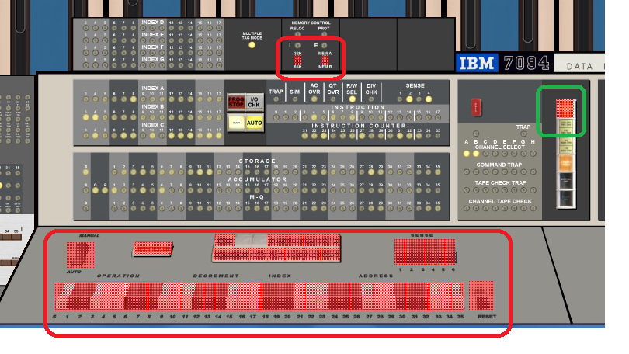

As a convention:
- power button on control panel (the one inside green rounded frame) quits SimH simulator by issuing bye scp command.
- The GUI window close button also quits SimH.

When the mouse pointer is into the Control Panel window, its shape will change according to following rules

- When CPU is running (thus the control panel is refreshed and responsive), the mouse pointer will be an arrow. If the pointer is placed on a clickable control, it will be changes to a hand

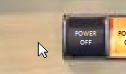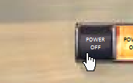

- When SimH is displaying the SCP prompt sim> the CPU is not running. If CPU is stopped, GUI window is not refreshed nor polled, so it will not react to mouse clicks (this is indicated by a slashed circle).

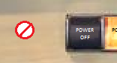

When CPU is stopped, GUI refresh and clicks reactions occurs on next scp command execution. Issue a SET CPANEL ON command on sim> prompt at any moment (or just press enter) to refresh the GUI window and see the results of previous scp command.

If the user clicks on control panel and moves the mouse without releasing the mouse button, then the control panel window will be moved on screen.

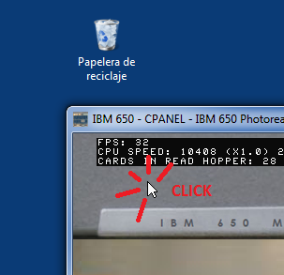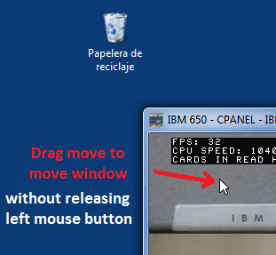

This is handy when control panel window is zoomed and does not fit on screen.

When moving the Control Panel window by dragging the title bar (the standard move procedure), the GUI image stop being updated but the simulation still running. When moving the window by clicking in the image and dragging the mouse, the GUI image will not freeze and will be updated as the windows moves.

Control Panels can be big. With + and – hotkeys it is easy to resize the window at will. But when size is small, it can be difficult to read keys/switches labels.

On clicking on right mouse button, a tooltip will popup with showing the control panel image under the mouse at 100% scale.

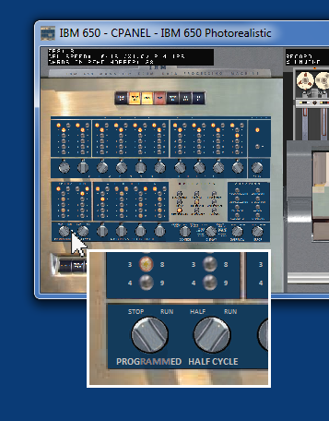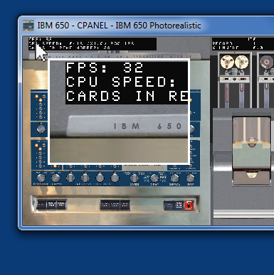

Dragging the mouse over the window while right button is kept pressed will show the contents on tooltip as button moves.

The tooltip window is closed automatically moving the mouse over it.

Interactive Mode

When simulated CPU is running, control panel is operating (shows info and reacts to mouse clicks) as callbacks are being called on events by SimH simulator.

Nevertheless, when simulated CPU is stopped, SimH can be either executing scp commands in an script, or waiting for scp commands from user on console prompt.

During script execution, at the end of each scp command executed, control panel is updated and callback events are processed.

But during user console input at prompt, SimH is blocked on fgets call waiting user to type a command and press enter. Thus the whole control panel is not responsive to mouse clicks, GUI close button, nor is updated. This situation is signaled to the user by the slashed red circle mouse cursor shape.

When user press enter, the GUI is updates once. This means you can click on GUI, that appears to not respond. Just press Enter on sim> prompt to see the updates on GUI

If scp command set cpanel interactive is issued, SimH transfer the control of simulation from scp command line to control panel. SimH then refreshes control panel and calls mouse events in the same way as when CPU is running. This allows to control the simulation from control panel in the real computer. CPU can be started and stopped while into interactive mode. If CP issues a scp command, the scp command is executed, but returns to interactive mode.

When in interactive mode, no scp command can be type on console, as set cpanel interactive command still in execution. To terminate interactive mode and regain control on console, the user can either

- press Control-E on console or on GUI. (or any other defined as WRU character)
- Press Enter on console

Hot keys for control panels can be used even when console has the focus

SCP commands

General command syntax:

SET CPANEL parameter[=value_tring]

No spaces can be inserted between parameter, the equal character and the value string. All parameters and options are case insensitive

SET CPANEL ON

Load the control panel definition file, process it, and open a GUI Simulator Window for control panel. Controls defined are drawn on it.

SET CPANEL OFF

Closes the control panel simulator GUI Window. If this scp command is issued from control panel, the interactive mode is turned off.

SET CPANEL OPTION = <NONE> | name | name / param

Defines an option with the given name that can be tested for existence in DF with tags ifdef, ifndef or elseif. Maximum len for Name are 32 characters. Use A-Z, 0-9, and special symbols expect spaces, commas and /.

If <NONE> is used, all options are deleted.

Options can have parametrers using a slash (/) as separator. No spaces are allowed between name and param. If name already has been defined with different params, the new given params replaces the old ones.

Note that options enabled or disabled are evaluated when processing DF with set cpanel on command. This means that set cpanel option must be issued before set cpanel on, and subsequents set cpanel option will only have effect on next set cpanel on.

SET CPANEL INTERACTIVE

Allows to operate the control panel in an interactive way. This command returns when user click on GUI window close icon (or if control panel issues a set cpanel off command) or user press the WRU key (default Control-E) either on console or in GUI.

SET CPANEL PRESS = name

Simulates mouse clicking on given control name. Must be a single control, cannot be a control array name. This command allows to script the operation of control panel.

SET CPANEL STATE = { <ALL> | name } / { * | n }

Forces on GUI window the state of given control to n, so it can be seen on this state. If a control array name is given, all the individual controls belonging to control array are set to the state n.

If <ALL> is given as name, all controls state are set.

If an asterisk (*) is given instead of a state number, the control is reset to normal operation.

This command is useful to assist the creation and debugging of DF.

Example: simulate the light test mode on control panel (light all, wait the user to press a key, the return to normal operation)

set cpanel state=<all>/1
!pause
set cpanel state=<all>/*

SET CPANEL MARK = <ALL> | <NONE> | name

Marks on GUI control panel window the given control, so it can be identified. If a control array name is given, all the individual controls belonging to control array are marked.

If <ALL> is given as name, all controls that have OnClick event callback are marked (thus showing the clickable controls).

If <NONE> is given as name all marks are removed.

This command is useful to assist the creation and debugging of DF.
Pressing Control-T on GUI is the same as issuing this command.

SET CPANEL TICKCOUNT = 0 | 1

Set to 0 to disable variable intensity of controls based on tickcount. Each control changes at a maximum rate of 30 FPS.

Set to 1 to enable them. The default value 1 is set on attach.

SET CPANEL LIST = <ALL> | name

List the properties defined in control panel definition file for the given single control name, or control array name.

If <ALL> is given as name, then all controls defined will be listed, and in addition

- the number of defined/free controls.
- The defined options

SET CPANEL SCALE = n

Sets the GUI window scale. Default is 100 (GUI has same size as defined in control panel definition file). Use 50 to have a GUI window of half size. Use 200 to have GUI window at double size. n ranges from 10 to 200.

This command can be issued before displaying GUI window with set cpanel on.
Pressing Control-Y on GUI is the same as issuing this command with scales 100 and 50

SET CPANEL POS = x / y

Sets the GUI window position at screen coordinates x,y. By default, GUI opens centered on screen (coordinates can be negagative).

ATT CPANEL file

Define the control panel definition file to be used. File is opened to check it can be read, and then is closed, so it can be modified even if attached. It is opened again, read and closed again on set cpanel on.

Attach also resets the options defined. The normal sequence for loading panel is:

- Attach DF file
- Set options for that DF (if any)
- Set cpanel on to show the GUI window

DET CPANEL

Detach control panel definition file

Defaults

SET CPANEL OFF, SHOWFPS=0, TICKCOUNT=1, SCALE=100, no file attached, no options defined

CPANEL device cannot be disabled, it is allways enabled.

If CPU is stopped, GUI window is not refreshed nor polled, so it will not react to mouse clicks. Refresh and clicks reactions occurs on next scp command execution. Issue a set cpanel on at any moment to refresh the GUI window and see the results.

When Simulated CPU is executing code, clicking on the close button of GUI windows ends the emulation (same as bye scp command). If Simulated CPU is stopped, the GUI close button does nothing. To just close the GUI window, use the SCP command set cpanel off.

Debugging

Several debug levels are provided.

set console -n log=console.txt

This SCP command generates a console log. The switvh –n instruct to overwrite erase any previous file that exists. If no –n is provided, console.txt file is appened

set debug -q stdout
set debug -q -n debug.txt

These SCP command allows to generate debug messages. Defines where the debug messages should be sent: to be show on stdout/console (first command form) or redirected to a file (second command form). Use one of these two scp commands, but not both. –n switch overwrites existing file. –q switch (quit) suppresses the debug active scp message.

set cpanel debug=df

This SCP command activates the debug messages for Definition File processing.

set cpanel debug=cmds

This SCP command activates the debug messages for command processing

set cpanel debug=refresh

This SCP command activates the debug messages for refresh processing

set cpanel debug=sdl

This SCP command activates the debug messages for SDL events processing. Note: SDL processing is done in SimH in another thread, so SDL debug messages does not share the common DBG() form:

DBG(21667)> CPU CMD: Exec 1967: 10 AUP 1970 1977
DBG(21670)> CPU DATA: ... Read 1970: 0000000010+
DBG(21670)> CPU DETAIL: ... ACC: 0000038072 8690001989+, OV: 0
SDL: SDL_WaitEvent: status 1, USEREVENT, DRAW (event.user.code 5)
SDL: vid_active 1, call SDL_WaitEvent

It is allowed ot issue one or several set cpanel debug=xxx commands, of to combine them in one command: e.g. set cpanel=df;cmds;refresh;sdl

Ways to create a Control Panel

Using tags to generate graphics and texts

In this approach, only DF is needed. This file defines the visual artifacts needed. An example of this approach is used by hp2114_basic.ini

This is the fastest and simpler way to model a control panel. No external files are needed.

Using one PNG file that holds several states

In this approach, among DF file, only one .png image is used. In PNG image, in addition of control panel background, an image is supplied for each states. E.g. for light on, and off. The states for controls refers to the image and select the X,Y coordinates for each state. An example of this is hp2100_basic.ini

This is a good approach when control states visuals are similar of a great number of controls.

Using several PNG files, one for each state

In this approach, among DF file, several .png image are used. This is a good way to model complex control panels. On file is the panel with all controls at state 0, other image is the same panel image but all controls are on state 1, and so on. On DF, control states refers to same coordinates X,Y, but refers to different images.

An example of this is ibm709_photo_512p.ini

Panels done so far

HP 21XX family
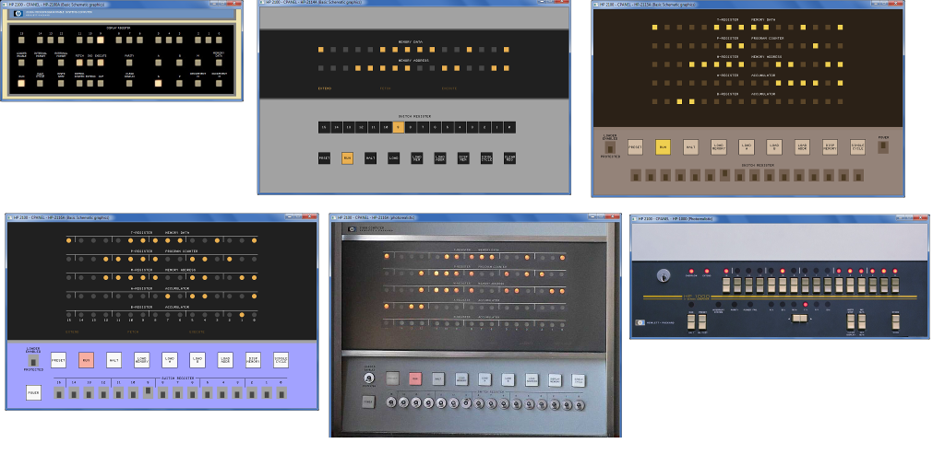

IBM 700/7000 family
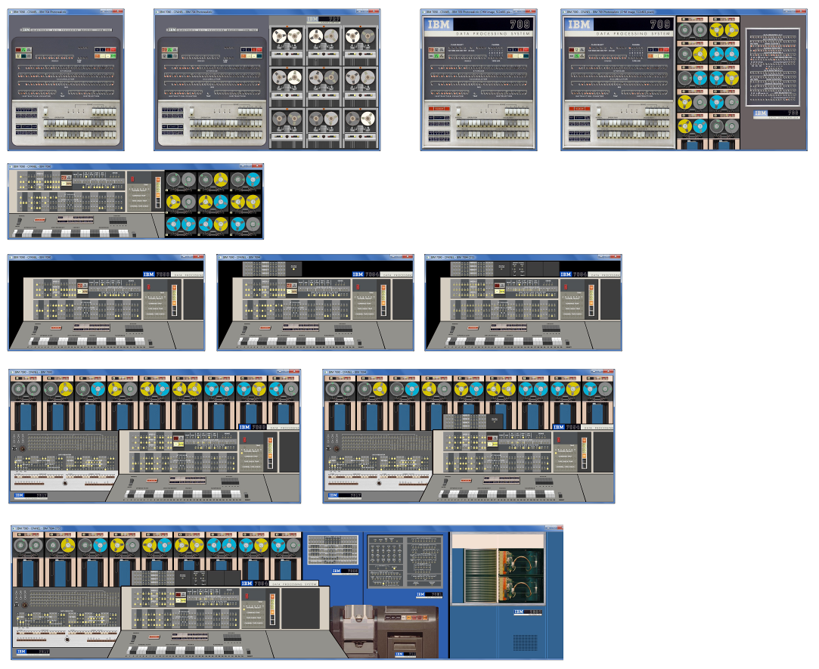

IBM 650
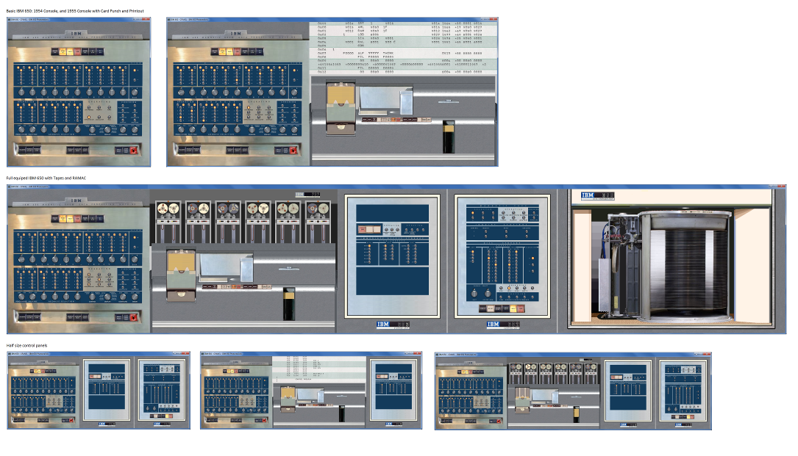

IBM NORC

